Question Two: Does electoral success lead to quantifiable benefits for contributors?

So far, through our exploration of campaign financing and how that should color our views on campaign financing, we showed that there does seem to be a strong, positive association between campaign contributions and electoral success. However, this is only part of the narrative in support of campaign finance reform. Proponents of campaign reform also argue that due to the vast sums of funds involved, the candidate becomes indebted to her largest backers. As a result, the candidate pays back those debts through kickbacks in the form of favorable policy proposals and other legal treatment. This question does its best with the data at hand to address that argument.

In the exploratory stage of answering this question, we investigated the straight correlations between industry performance, votes received, and the percentage of race funds received (the latter two being good proxies for the winner, as shown in Question One).

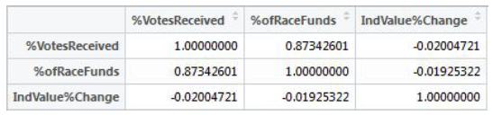

Unfortunately, since the correlation showed almost no relationship, this was not a good sign for the analyses to come. However, undeterred, we continued our analysis of the financial data by comparing performance in election years to non-election years in the hopes of finding some difference or boost in performance.

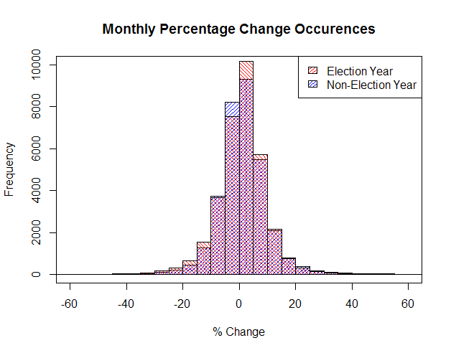

More bad news! Since the monthly percentage change in stock value doesn’t seem to be related at all to the election cycle, it looks like there may be less influence than we had hoped. However, perhaps there is something we are missing about the relationship between candidates and industries that might be able to help us parse the data further.

With that in mind, we analyzed the relationships between industries and candidates using a network. We did this on the full data set without outliers. The following network shows a subset of winning Senators from 2014 as nodes. Connections are formed between candidates that shared at least one of their two top contributing industries.

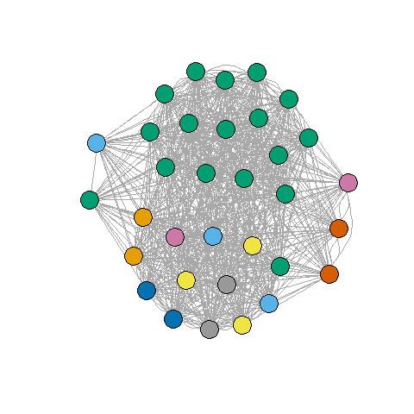

The main take-away from this network is that the candidates are hopelessly intertwined by industry. One possible conclusion from this network is that industries hedge their bets and support many different candidates to be sure they end up on the winning side in one way or another. However, a more likely explanation in this case is that our data is just not good enough for this sort of analysis. The bins are just too coarse to find the relationships that we are hoping to find. The coarseness comes directly from the binning of the Open Secrets data in order to allow it to merge to the financial data. Given these disappointing results, it seemed better to focus our effort on expanding our other research questions.

Other methods that we considered for exploring the chain of campaign contribution to election to contributor gains, but couldn’t complete due to the form of our data, included “What are the time series effects of an election and industry contributions?”, “What is the influence of Super PACs and individual contributions on campaign success?”. Unfortunately, we simply don’t have the granularity of when contributions are made in order to assess time series relationships. The only time series data that we had was the stock data. In the case of the second question, although Open Secrets has PAC and individual contribution information, it was not in a scrapable form and their API restricts accesses to a limited number of records per day. Furthermore, even if we had setup a strategy for gathering that information, it was only available for one or two election cycles.